Assignment 1: The Searchable Athletes Page

Due Date: 5th September 10 pm

Value: 10%

In this practical you will build a searchable MySQL database with an HTML front end. This year we are focussing on the New Zealand Olympic Medallists. This assignment will be marked in class as per our checkpoint exercises with the attached marking schedule. Split the task into two parts:

- Write a PHP file to create the tables call it createAthletes.php, in this file code a select to join the tables, show the resulting table in a separate include file.
- Code a controlling PHP file (sportSearch.php) that produces a search (drop down) box or the resulting table.

To prove that you have completed the assignment on time please save your two php files into a folder called your name and paste into I:\COURSES\AITEIT3\Assessments Swallow Box\Web 2- assignment 1

Making the database tables- part one

You will need a minimum of two tables, create an athlete’s table and an event table. Suggested fields:

Athlete Table |  | Event Table
athleteId |  | eventId
lastName |  | sport
firstName |  | event
gender
image
eventId
medal

Each table will need a primary key, db2 people will want to set up a foreign key.
Data may be found on the I:drive medalists.xlxs. Image files were downloaded from OlympicChannel.com (Photos: Reuters). All the photos have been copied for you; they are in the folder labelled rio.

Populate your tables with at least 15 records; make sure you have at least 5 different sports. It should then display all the records in the database to verify success. Make sure you display the images, not the image file names.

Making the Front End-part two
After your tables are created, you need a web site to access them.
- This site should consist of two screens, produced by a controlling PHP file.
- At first access, the user will see the search page.
- They will be able to type a sport into a search box (or select from a drop down box) and see all the medallists displayed neatly in a table on the display page. To gain maximum marks you should code a dynamically generated drop down box. Make the first option in the list “show all”, every other sport comes from your table. Have the list come out alphabetically sorted.
- The display page will contain a “Return to Searching” button that will put the user back to the initial screen (search page).
- The site must respond gracefully to failed searches (i.e. those which return no records). You may skip this step if you manage to get the Dynamic list box operating (see notes below) because it will be impossible for the user to make an error.
- Please theme your pages appropriately and lay out in an attractive manner.

Text Search Box (will not get you top marks)
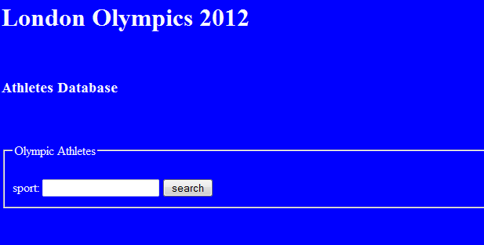
Figure 1 Entry Screen with Search Box and Submit Button

Dynamic List Box (will get you top marks)
Using a text box for user input is error-prone: users may make typographical errors, enter non-existent sports, etc. When there are only a limited number of correct options, it is much safer to provide a list box (using the <select…> tag). Since you might be adding new sports to your table, you cannot hardwire the <options> in your list box, you must determine them at runtime by querying the database. Modify your controlling php file to dynamically populate a list box for sport selection. (Hint: Consider the DISTINCT modifier to a SELECT query.)

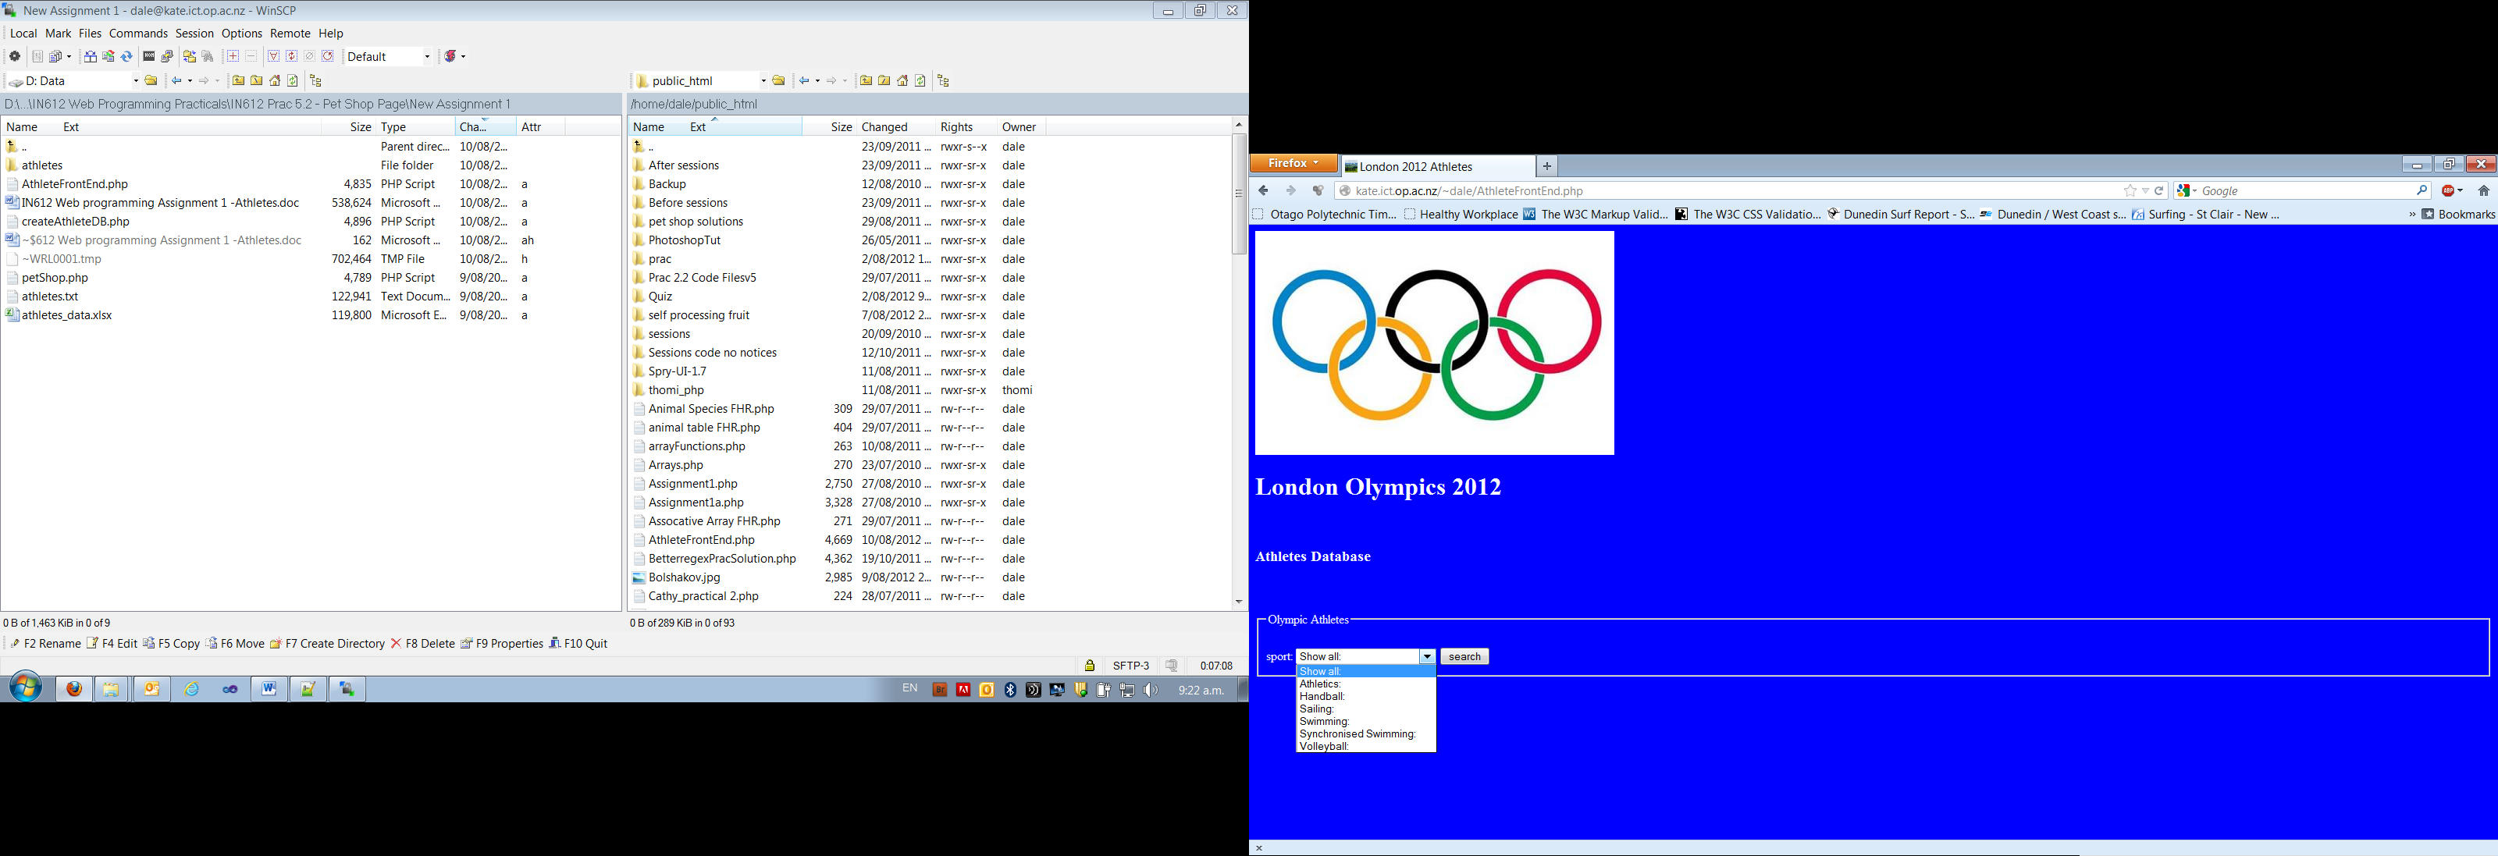

Figure 2 Search with a drop down box

Assignment 1: The Searchable Athletes Page

Author: Mark:
 | Range | Your mark
createAthletes file- part one:
Create the athletes table | 1
Create the events table | 1
Primary keys | 1
Error screen file | 1
Output screen showing all fields in a joined table | 1
Images displayed not file names | 1
Data inside a styled table, separate css file | 1
Data output screen validates | 1
Inserting records  15+ insert strings  One prepare statement or another efficient way | 1  3
Search file: part two
Search is a text box, failed search returns empty table  Search is a text box, failed search returns appropriate message  Search facility uses list box but is hard coded  Search facility uses list box automatically populated no list all option  Search facility uses list box automatically populated with a list all option | 1  2  1  5  6
Back to search screen button or equivalent functionality | 1
Validates | 1
Good looking web site (subjective scale) | 1 2 3
Page header comments (on all files) | 1
Line comments | 1
Code Layout | 1
PHP functions written | 1
Independent study:
Minimum of 3 tables (associative table) | 2
Foreign key | 1
Read values from a spreadsheet | 4

